**Airflow installation using Docker:**

1. **Download docker desktop using the following url:**

<https://docs.docker.com/desktop/install/windows-install/>

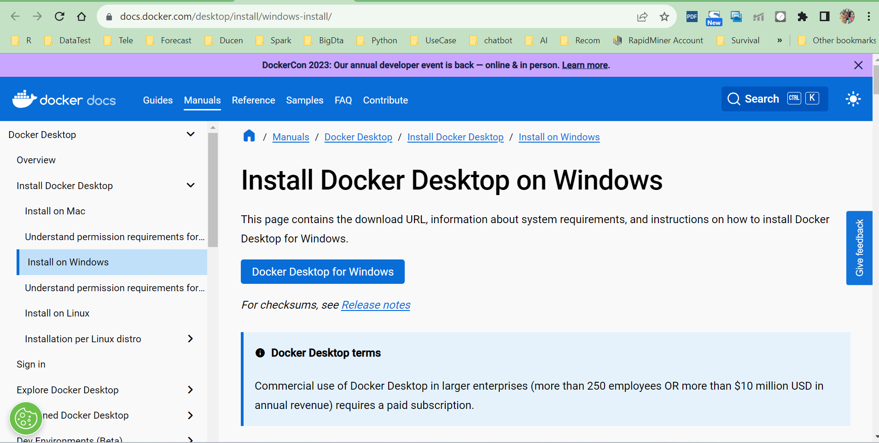

1. **Once installed, check whether the you have linux updated else run the following command in your system to update the linux os:**

“ wsl –update”

And check the docker version using the following command:

docker --version

1. **Then install visual studio code from the url:** <https://code.visualstudio.com/download>

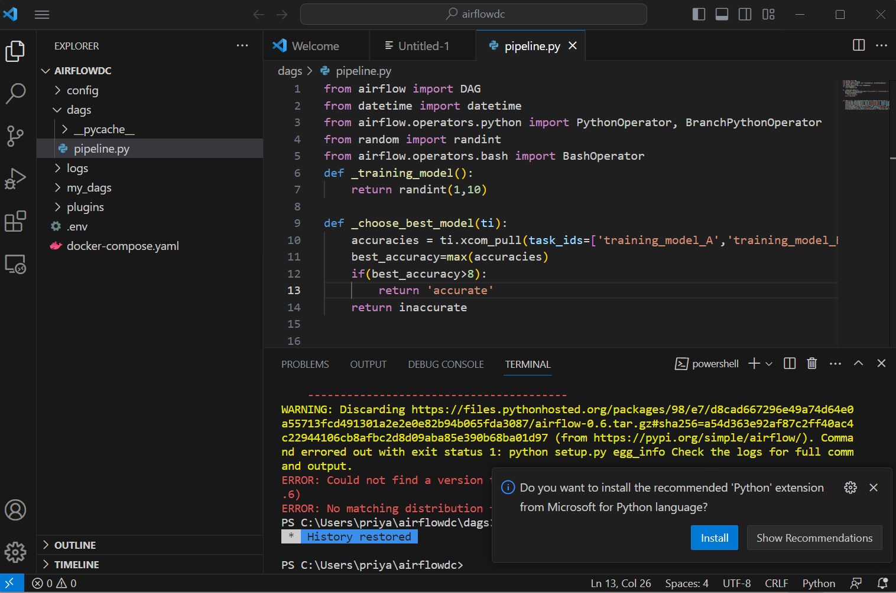

The folders created in the location will be considered as a docker composer which compose the docker image and runs the script as a dag in Airflow, and create the subfolders : dags, logs, plugins

1. **In order to make the docker compose up, run the following commands in the terminal:**

>>docker ps

>>curl 'https://airflow.apache.org/docs/apache-airflow/2.7.0/docker-compose.yaml' -o docker- compose.yaml

>>docker-compose up -d

1. **Go to the browser and open the following url:**

<http://localhost:8080/home>

default username and password is “Airflow”, “Airflow”

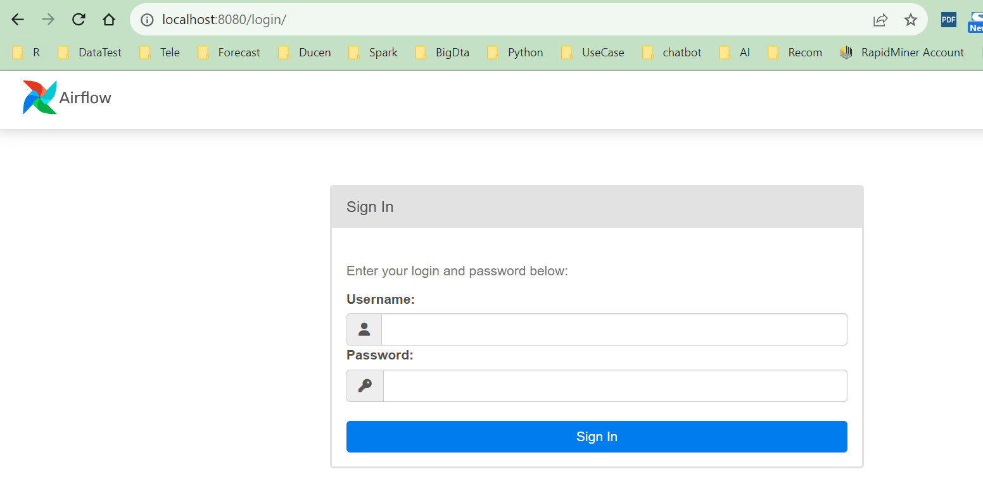

Sometimes it takes 2 minutes to load the site

**6: Create the sample DAG using the following script below:**

from airflow import DAG

from datetime import datetime

from airflow.operators.python import PythonOperator, BranchPythonOperator

from random import randint

from airflow.operators.bash import BashOperator

def _training_model():

    return randint(1,10)

def _choose_best_model(ti):

    accuracies = ti.xcom_pull(task_ids=['training_model_A','training_model_B','training_model_C'])

    best_accuracy=max(accuracies)

    if(best_accuracy>8):

        return 'accurate'

    return inaccurate

with DAG("my_dag", start_date=datetime(2023,8,21),schedule_interval="@daily", catchup=False) as dag:

    training_model_A=PythonOperator( task_id="training_model_A", python_callable=_training_model)

    training_model_B=PythonOperator( task_id="training_model_B", python_callable=_training_model)

    training_model_C=PythonOperator( task_id="training_model_C", python_callable=_training_model)

    choose_best_model= BranchPythonOperator(task_id="choose_best_model", python_callable=_choose_best_model)

    accurate=BashOperator( task_id="accurate", bash_command="echo 'accurate'")

    inaccurate=BashOperator( task_id="inaccurate", bash_command="echo 'inaccurate'")

    [training_model_A,training_model_B,training_model_C] >> choose_best_model >> [accurate,inaccurate]

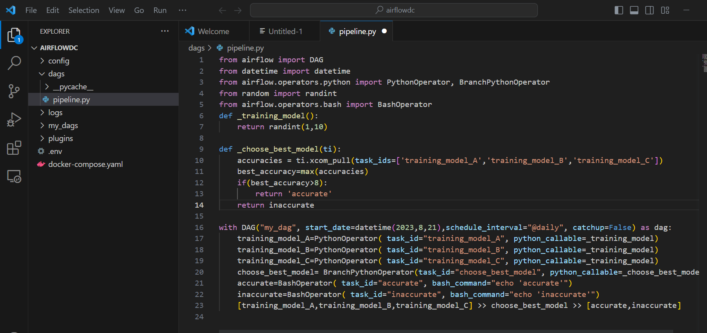

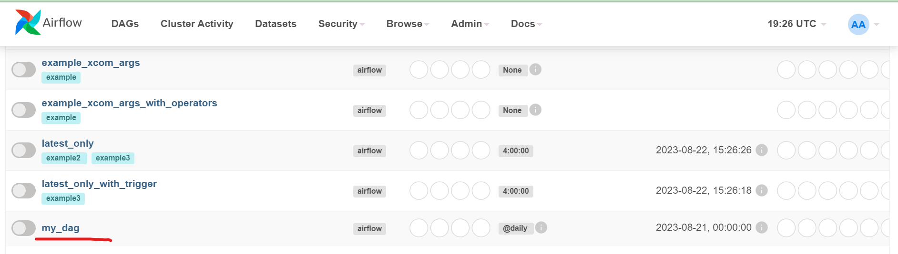

The dependencies on the tasks or the operators can be seen under the graph section as below:

